Create tool

I want to create a configurable-monitor tool so I can track the volatility of top 1000 coin prices in coinmarketcap.com. The tool will show all the coins that meet all of the configurations we set. 3 main configurations-indicator that this tool will need calculate are   
**% change** of each coin at the moment with exact price from 3’ 5’ 15’ 1H 4H ago

**candle count :** we calculate how many 1H candles 14 days ago of each coins which has CHANGE > 4% and <-4%

**% change volume :** we calculate how current volume has been changed comparing to **average** 48H ago

This application will be a server-client application with an UI and admin console pages.

1, Server side  
  
# Preparation  
- 1000 top coins in coinmarketcap.com ( exclude stable coins )

- Collect information from coinmarketcap API https://coinmarketcap.com/api/documentation/v1/ and binance api <https://www.binance.com/en/binance-api> ( or from any sources if you know ) of those coins

-Real time price

-Exact price from **3’ 5’ 15’** 1H 4H ago ( **15 candles 1 minutes ago** and **4 candles 1H 4 hours ago** )

-> to calculate **% change**

- All 1H candles from 14 days ago

-> to calculate **candle count**

-Market cap ( today ) $ mil

-Volume: 48 candles 1H ago  
-> to calculate % change volume

- After collecting all the information we need, start to calculate our indicators ( each indicator we will establish 1 module ).

- Server configuration limitation: core i7 gen13 8 core 16 thread 32GB RAM

# Module candle count

- Separate to 2 time frames: 7 days and 14 days

- Calculate each coins : how many candle had the CHANGE >4% and <-4% on 7 and 14 days ago ( we can config this 4% to different numbers )

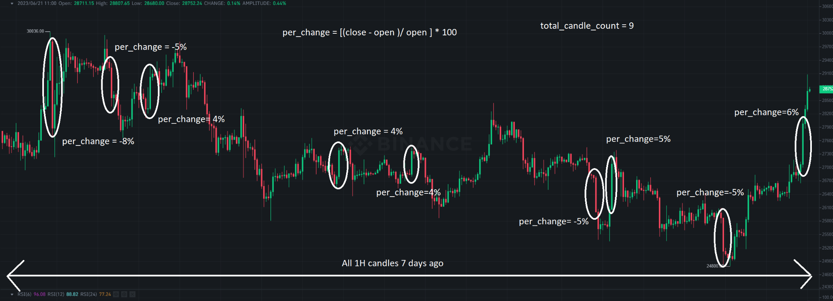

# Module % change

Using this formula

%change = [(current price - close_price x ago )/current price ] * 100

**- Calculate % change of each coin at the moment with Exact price from 3’ ago**

**- Calculate % change of each coin at the moment with Exact price from 5’ ago**

**- Calculate % change of each coin at the moment with Exact price from 15’ ago**

- Calculate % change of each coin at the moment with Exact price from 1H ago

- Calculate % change of each coin at the moment with Exact price from 4H ago

# Module % change BTC

- Calculate % change of BTC at the moment with Exact price from 3’ ago

- Calculate % change of BTC at the moment with Exact price from 5’ ago

- Calculate % change of BTC at the moment with Exact price from 15’ ago

- Calculate % change of BTC at the moment with Exact price from 1H ago

- Calculate % change of BTC at the moment with Exact price from 4H ago

**Get % change each coins on previous module subtract (-) % change BTC ( for each timeframes ) show the gap value on UI**

# Module % change volume

Using this formula

% change volume 48H = [ Volume current - avg ( 48 volume records before ) ] / Volume current

avg ( 48 volume records before) = [sum ( 48 volume records before) / 48]

# Module Market cap (circulating supply)  
- Get data of Market cap today ( millions $ )

**# Update frequency**

Module % change

-> Real time for best ( raise to 1 minute if reaching limitation )

Module % change volume

-> update hourly

Module candle count and market cap

-> update daily

2, User side  
# Step0: Login from UI

# Step1: Select a combination of settings

User can edit and select 1 or more indicator below ( those indicator depend on above module that we calculated )  
The list of settings :

% Change 3’ ( equation ) … %

…….

% Change 1H ( equation ) … %

% Change 4H ( equation ) … %

Candle count … days ago ( equation ) …

% change volume ( equation ) …

Market cap ( equation ) … millions $

**These settings/indicator can combination using operators “AND” and “OR”**

# Step2: Send this request to server

1, Run this request continuously,

2, if any coin meet all of conditions of this request we will show it on UI -> send a notification on Telegram ( set a timer 15’ to temporary **not** run this request on this specific coin for this user to avoid spamming notification )

3, Open a tab-chrome of that coin on coinmarketcap.com

For example if AXS meets all of conditions -> open tab-chrome  
<https://coinmarketcap.com/currencies/axie-infinity/>

4, Each user will send 1 request personally and server will handle all requests independently and return results to all users

5, Require server can handle 200 request

3, User Interface

**User side**

1, Login page

2, Setting page (step1 from user side )

3, Personal information page ( user can edit and update )

4, Final record table ( they can go back and edit the setting page for new request )

5, Notification history

**Admin side**

**1,** User management page

1, Activation status -> if no -> user can not access to “Setting page” and “Final record table”  
2, Expiry date -> when user reaches to this date -> Activation status set to “no”  
3, List coin that user can access to ( 3 options : 100 first coin, 500 coin and all coins )

4, Name, Email, Mobile …

5, Telegram

4, Example of a workflow

# Server side  
After collecting all data and calculated all modules we will have a final record table looks like below ( this table will change continuously on real-time)  
  
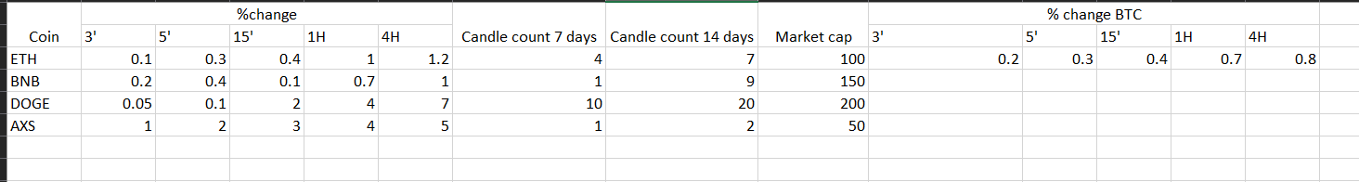

**-> this can be as user interface also, when we config indicator, for each cell of coin which meets the condition -> the cell will change color -> the more cells that changes color the coin will put on top automatically**

# User side

User set a combination of indicators(request ), an example as below

% Change 1H >= 4 %

Candle count 7 days ago <= 2

Market cap < 100 mil $

With this setting we see that request meet all conditions of AXS coin at the moment -> server sending a notification to user -> this coin (AXS) will put on top of UI  
  
